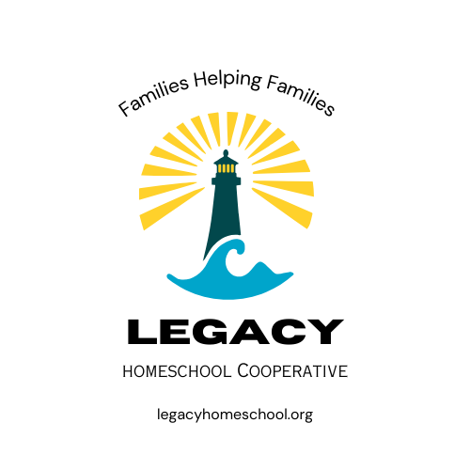
Policies/Procedures
&
Standards of Conduct

All Legacy members need to abide by and stay within the bounds of our Vision, Policies/Procedures and Standards of Conduct.

OUR VISION:
As homeschooling families, we are coming together in friendship and learning. This is achieved by creating an uplifting and respectful environment with a variety of classes led by parents. We believe there is value in many philosophies of learning and curriculum. We strive to enhance, not replace what we are learning in our individual homes, as we are stewards over our own families.
At Legacy, we strive to be like a lighthouse. A place of safety, strength, hope and direction. We can help uplift and encourage each other by sharing our light!

POLICIES & PROCEDURES
FAMILY MEMBERSHIP FEE
The family membership fee goes to operational costs that include building rent, insurance, website fees and supplies. It is paid each semester before you can register for classes and is non-refundable once registration begins. The fee is determined according to the number of families attending Legacy. Our goal is to keep this fee as affordable as possible.
CLASS FEES
Class fees are for the supplies of the specified class (and occasionally the specified hired teacher). Class fees will be determined by the individual class Guides, keeping in mind our goal is to keep fees as reasonable as possible. We are trying to aim for $3- $30 per student, per class. We encourage the pulling together of resources by way of used supplies or donations etc. Guides may choose to have parents purchase supplies for their child attending, instead of or in addition to a class fee. If a student decides to drop a class after the semester starts, it is up to the Guide of the class whether that student will receive a refund (full, partial or none).
SAFETY
We encourage the buddy system for teachers and children.
Parents are required to remain on the site while their children are taking part in classes and activities. If you must leave for any reason, you MUST take your children with you. If you are sick or cannot come to co-op, your children must stay home with you.
Children are not allowed outside unless they have their parents’ permission, or they are with their class Guides.
All visitors to Legacy Co-op must be approved by the Co-Captains prior to Co-op.
LEGACY GATHERING
Gathering as families is an important part of Legacy Homeschool Cooperative. We highly encourage ALL to attend. This is to encourage unity and friendship building within our community. This time is devoted to keeping informed with important co-op announcements, getting more acquainted, sharing our talents, and encouraging each other. This is achieved through thoughts, prayer, and the pledge of allegiance.
EMERGENCY/SNOW DAY POLICY
In case of severe weather or other extenuating circumstances, you will be notified via email or GroupMe app of the cancellation or delaying of co-op.
ILLNESS and ABSENCE POLICY
Members should not attend Legacy activities if they are sick or are experiencing any symptoms of illness (ex. fever, virus etc.).
If you are sick or need to stay home with a sick child and are supposed to teach a class, please promptly contact your Co-Guide or another parent to substitute for you. Also contact either one of the Captains and let them know.
If you are going out of town and are teaching, please find a substitute parent ahead of time and make sure the Co-Captains and students in you class are aware.
FACILITY RESPONSIBILITIES
We ask that all members respect the facility. We need to stay in the areas that we have rented. It is important that we maintain appropriate conduct while in the building so we can continue to rent this space. Clean-up responsibilities are to be completed immediately with everyone lending a helping hand. Many hands make light work!

DRESS CODE
In keeping with Legacy's vision, we ask that students and parents adhere to the following dress code.
- Fingertip length shorts and skirts, including rips in pants.
- Chest, back, midriff covered.
- No vulgar graphics or language.

CONFLICT RESOLUTION POLICY
If conflicts arise between children and/or parents, they need to be *resolved privately and respectfully. If either party is unsatisfied or a resolution cannot be made, they are invited to seek the assistance of a Captain to mediate. As a last resort, the conflict will be discussed among Co-Captains, and together they will make the final decision.
*Resolution- when all parties reach mutual agreement or understanding.
BEHAVIOR STANDARDS
-ALL Legacy members are expected to be respectful and kind to themselves and others, in and outside of the classroom, to act in such a way that our words and actions create unity and encouragement among Legacy families.
-Members need to avoid acting in such a way that is considered disrespectful, dishonest, offensive, intimidating, or rude. Members need to avoid gossiping to or about others and pushing personal beliefs in a way of trying to convert others.
-To avoid disruptions during classes, children not attending a class during a particular hour should find a quiet place to be under the supervision of their parent.
-The use of electronic devices, including cell phones, during classes should be limited, unless intended for instructional use. Electronics can be a distraction from the learning process. Please be aware of what you are sharing with other peers to respect their families’ preferences.
-Please do not bring items that are disruptive or that could cause damage.
-To respect each family, personal displays of affection (PDA) are Not Allowed at Legacy co-op. To avoid confusion, this policy applies to All Ages. What is considered acceptable and what happens outside of co-op is decided by individual families.
STUDENT RESPONSIBILITIES
1. Come to class on time. Not coming on time disrupts the class and causes you to miss important instructions.
2. Do not leave in the middle of class unless it is an emergency, or you have permission from the Guide.
3. Be prepared with supplies needed.
4. Be respectful of others, including their property. Keep hands and feet to yourself.
5. Be respectful of the building. No rough housing and destructive behavior. Use inside voices.
6. Respond appropriately to the Guides instructions.
7. Encourage and support one another in a gracious and kind way.
8. Students will be reminded by Guides of proper classroom behavior if needed.

PARENT RESPONSIBILITIES
1. Parents are responsible for guiding and directing their children, including knowing where they are. This includes making sure they are in class and not wandering the halls. This also includes the buildings surrounding areas.
2. Come on time. Be prepared to assume your responsibilities.
3. Pay membership fee and class fees on time.
4. Agree to follow policies/procedures, standards of conduct and signed liability release form.
5. Contribute by teaching/helping in the classes you are assigned to. We all can contribute because we each have life experience, knowledge, and personal interests to share.
6. Encourage participation without pressure. Encourage friendship building and inclusion.
7. Please promptly and kindly correct disrespectful behavior, or inappropriate language.
8. Promptly take care of the needs of your child when there is injury or misbehavior.

(Policies/Procedures and Standards may be changed or added at any time to meet the needs of the cooperative. Policies/Procedures and Standards must be presented, discussed, reviewed and approved by the Co-Captains.)

* Legacy Homeschool Cooperative Captains have the right to revoke memberships to anyone that persists in conducting themselves in a way that is contrary to Legacy Homeschool Cooperative's Vision, Policy/Procedures and Standards of Conduct.

